Sierra Duffey

Yoga Website

# The Thinking

As a “digital” native and someone working in web design, I know how important it is for anyone to have a personal brand and a website regardless of their business! I currently have a website for my photography work, but would like to take a totally different approach for a yoga website.

This website would be the main space for information about classes I may be teaching or events I’d like to host, details about private lessons, a contact page, and - my favourite - blog posts.

All the images I used for this design are just stock for now, but eventually I would like to do a photoshoot with a photographer to get proper yoga images! These would be great to use for bios (i.e. on a studio or gym’s website) as well as my personal site.

For the colours and look of the site, I decided to sort of go the opposite way of my photography brand (bright pink, black and white). I wanted the overall look to be minimal, soothing and calm. I’m also generally just taking this approach to my travel and landscape photography, so would be the overall look for my blog posts as well.

# The Site

This site is just one long scrolling page, with the navigation at the top acting as anchor points (they will bring the visitor to that section)

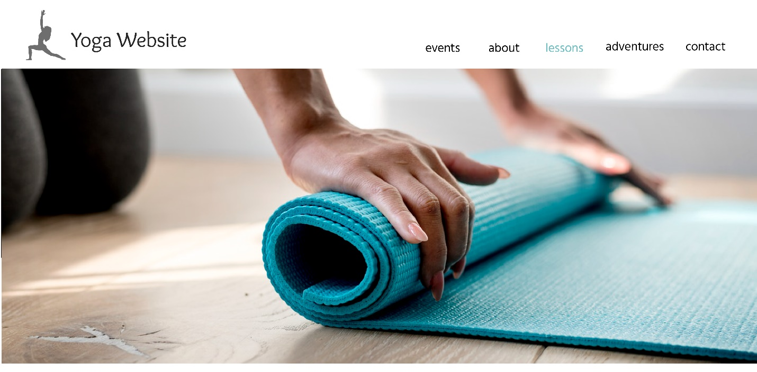

The top section of the website would have a really nice banner image (TBD) that would be something other than an asana. Right away I want to play with the concept that yoga is so much more than just poses, and that should be the first thing visitors see when they get here.

My “yoga” brand is yet TBD, since I already use simply my name and sierraduffey.com for my photography. A potential name I’ve been playing with for Instagram and a URL is Yoga Mae (my middle name).

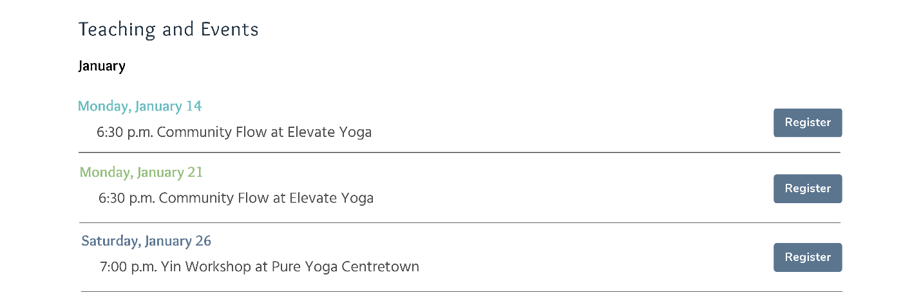

This second section shows upcoming classes or events on my schedule, and would ideally be tied to my Fitness Google calendar to automatically update. 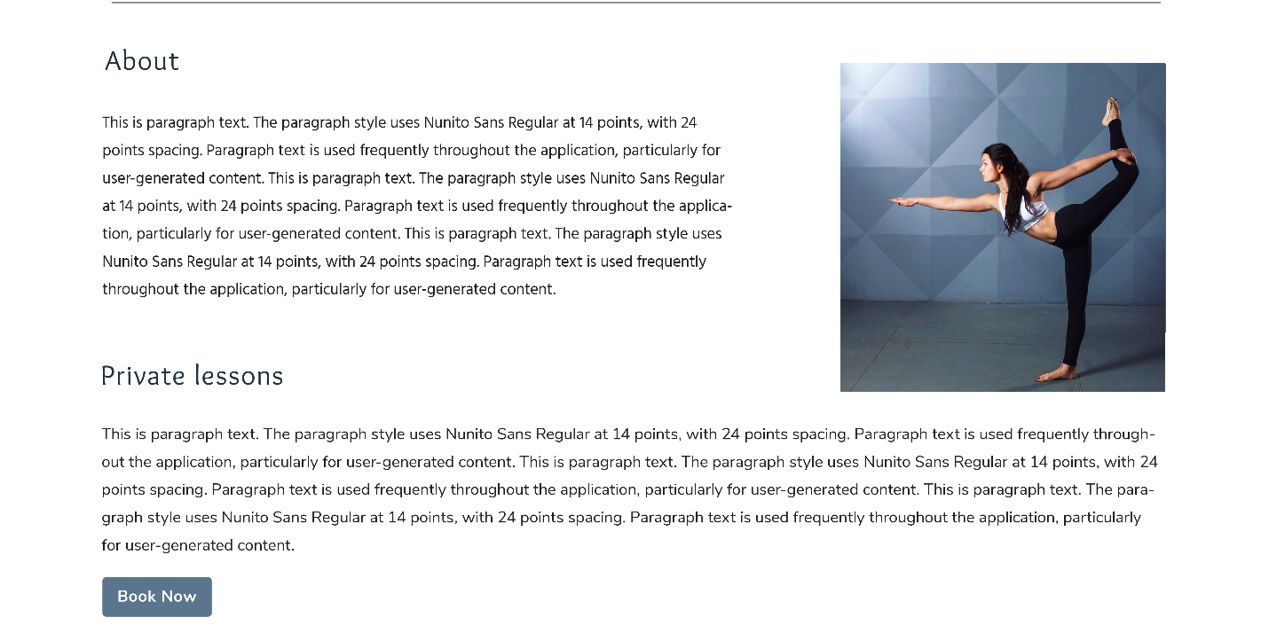

The third section would have a nice photo of me in one of my favourite poses, and a brief bio that talks about why I love yoga and how I started teaching! The Private Lessons section will have more information about the benefits of private or small group training, with a button linking to a scheduling app so people can book right away (either Square or Calendly).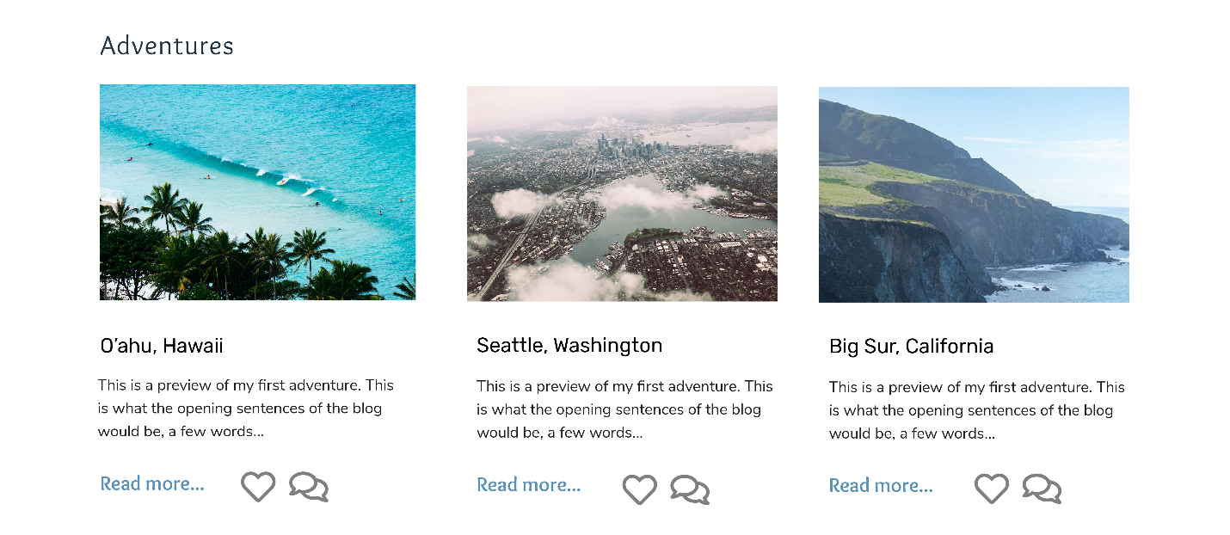

My adventures section is my favourite. This would be a carousel with a preview of each blog post. Blog posts would be on a separate page with similar styling and imagery to this one. These blog posts will be about my travels, yoga training I’ve taken, or other significant events related to yoga (i.e. starting a new regular class or service) All photos in the blogs will be taken by me, and have similar colours and feel. 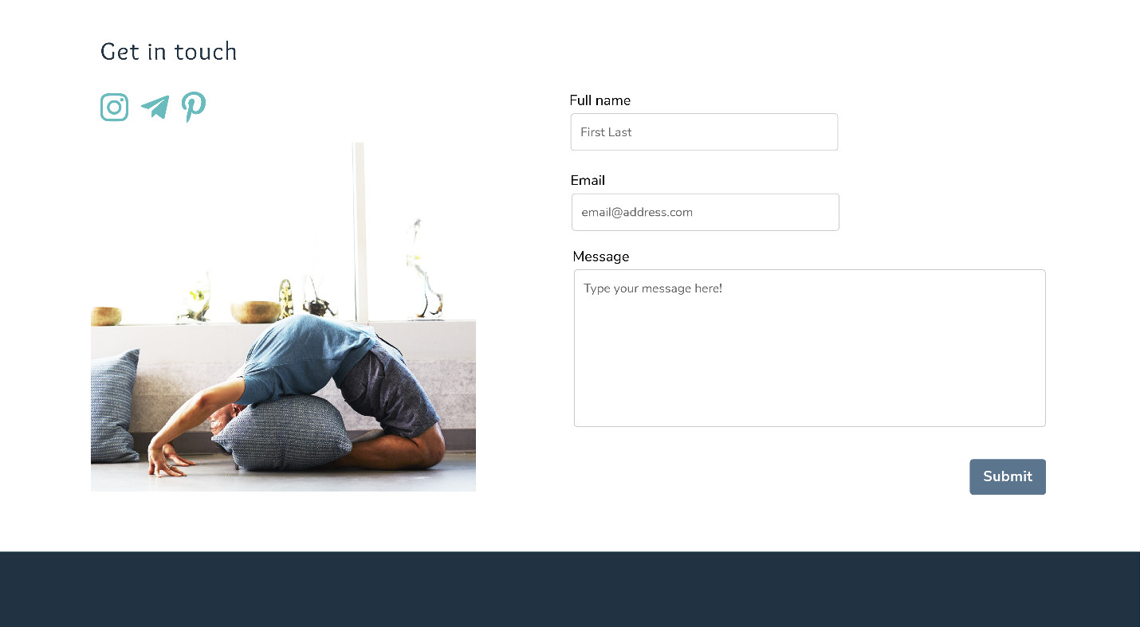

And lastly there’s a clean contact page where visitors can write me a message directly from the site, or find me on social media. The image could really be anything, but a photo of a client would be awesome.

# Plans for Development

Ideally when I go to develop this website, I will purchase my domain name, then hire a developer to help me with the actual code (I have lots of connections with developers!) I’d also like to use this site as an opportunity to practice my own coding skills.

The launch for this site is TBD, but some potential goals for launch is the beginning of 2020 or when I feel like I have enough regular teaching opportunities and content to post.